School of Computer Science and Artificial Intelligence

Lab Assignment # 3.2

Program : B. Tech (CSE)
Specialization : AIML
Course Title : AI Assisted Coding Course Code: 23CS002PC304
Semester  Academic Session Name of Student | : VI  : 2025-2026  : D.MANIDEEP
Enrollment No. | : 2303A52127
Batch No. | : 33
Date | : 13/01/26

Lab 3: Prompt Engineering – Improving Prompts and Context Management

Lab Objectives
- To understand how prompt structure and wording influence AI-generated code.
- To explore how context (comments, function names, and examples) helps AI generate more relevant output.
- To evaluate the quality, accuracy, and structure of AI-generated code based on prompt clarity.
- To develop effective prompting strategies for AI-assisted programming.

Lab Outcomes (LOs)
After completing this lab, students will be able to:
- Generate Python code using Google Gemini in Google Colab.
- Analyze the effectiveness of code explanations and suggestions provided by Gemini.
- Set up and use Cursor AI for AI-powered coding assistance.
- Evaluate and refactor Python code using Cursor AI features.
- Compare AI tool behavior and code quality across different platforms.

Tools Used
- Google Gemini (Google Colab)
- Cursor AI
- Python 3.x

Task Description – 1

Progressive Prompting for Calculator Design
Design a simple calculator program using progressive prompt enhancement:
- Start with only the function name

Add comments describing functionality
- Add usage examples
Analyze how each step improves the AI-generated code.

Step 1: Minimal Prompt (Function Name Only):
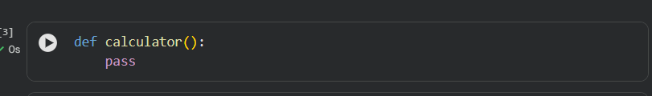
Observation
  - AI lacks context
  - No logic, parameters, or functionality

  - Output is incomplete and unusable

Step 2: Prompt with Comments (Added Context):
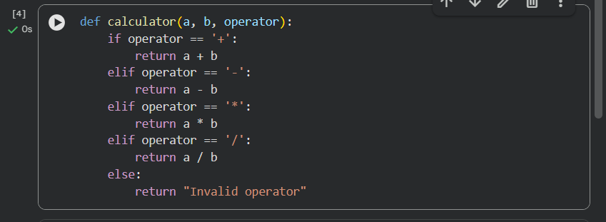
Observation
  - Correct logic implemented
  - Parameters inferred correctly
  - No input validation (division by zero not handled)

Step 3: Prompt with Comments + Usage Examples:
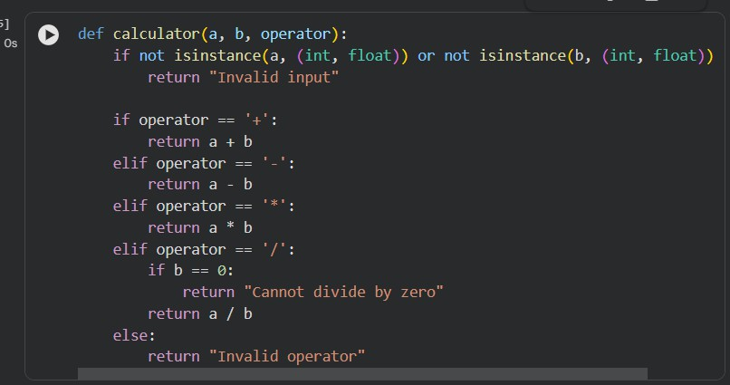
Observation
  - Input validation added
  - Division by zero handled
  - Code is robust, readable, and user-safe
  - Output format matches examples

Expected Output – Comparison Analysis Comparison of AI-Generated Calculator Code

Prompt Level Logic Quality Validation Robustness Code Clarity

Function Name Only | Very Poor | None | None | Very Low
With Comments | Good | Partial | Limited | Good
Comments + Examples Excellent Full High Very High

Task Description – 2:

Refining Prompts for Sorting Logic Objective:
To observe how refining a vague prompt into a clear, constrained prompt improves the correctness and efficiency of an AI-generated sorting function for student marks.

Step 1: Vague Prompt

Observation
  - Sorting order not specified (ascending or descending)
  - No validation of input type
  - Assumes marks are always valid

Step 2: Refined Prompt with Constraints
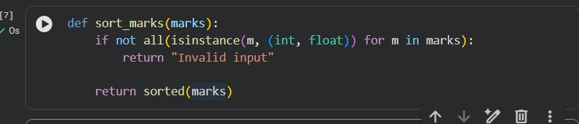
Observation
  - Sorting order clearly defined
  - Input validation added
  - Logic is more reliable

Step 3: Fully Refined Prompt
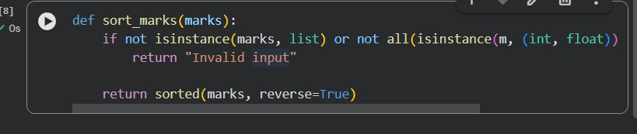

Expected Output – 2 (Analysis)

Prompt Clarity Sorting Accuracy Validation Efficiency
Vague Low None Medium
Refined High Partial High Fully Refined Very High Full High

Task Description – 3

Few-Shot Prompting for Prime Number Validation Objective:
To analyze how providing multiple input-output examples improves correctness and edge- case handling.

Few-Shot Prompt:
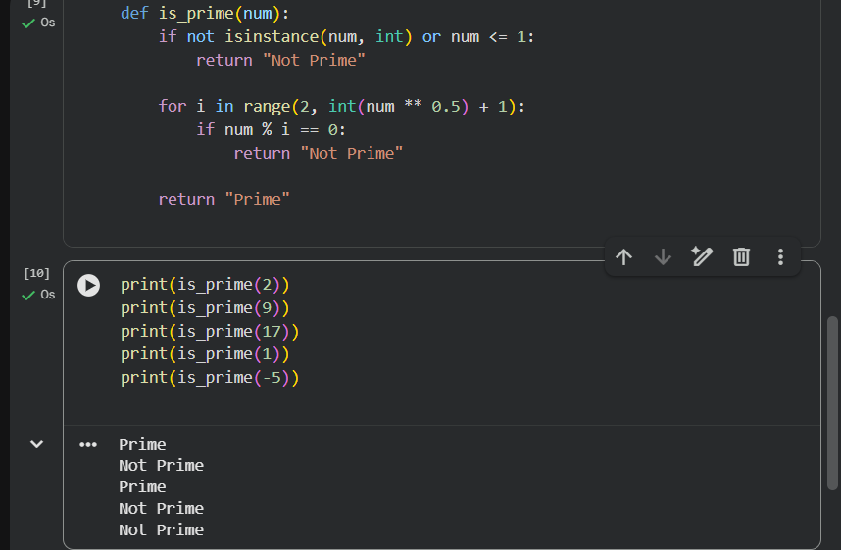

Expected Output – 3
  - Correct handling of 0, 1, and negative numbers
  - Efficient √n optimization
  - Clear output format

Task Description – 4

Prompt-Guided UI Design for Student Grading System Objective:

To generate a simple UI-based program that calculates total marks, percentage, and grade
using prompt guidance.

Prompt
“Design a Python UI program for a student grading system.
The program should:
  - Accept marks of 5 subjects
  - Calculate total and percentage
  - Display grade based on percentage
  - Show clear output”
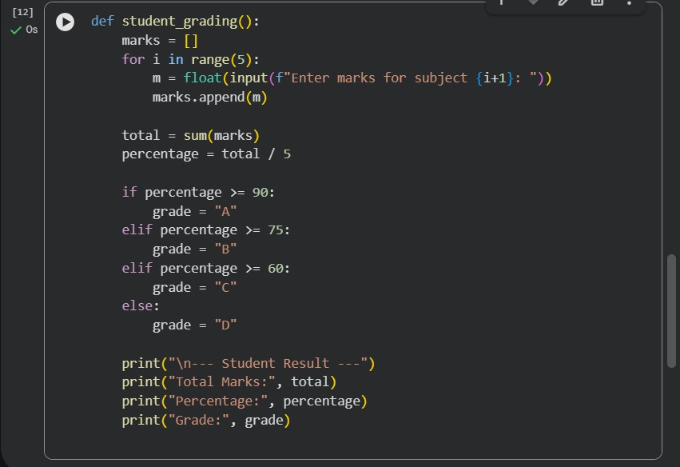

Expected Output – 4
  - Clean UI flow
  - Accurate calculations
  - Easy-to-read result display
  - Logic directly guided by prompt clarity

Task Description – 5

Analyzing Prompt Specificity in Unit Conversion Functions Objective:
To analyze how clearer instructions improve accuracy in unit conversion functions.

Prompt 1: Vague Prompt
“Write a function to convert distance.”



Issue:
  - Conversion direction unclear
  - No flexibility

Prompt 2: Refined Prompt
“Write a function to convert kilometers to miles.”


Prompt 3: Fully Specific Prompt
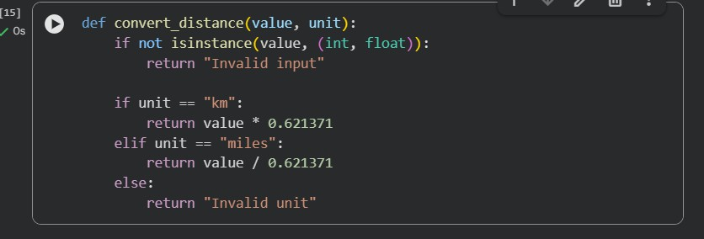
Expected Output – 5 (Analysis)
Prompt Type Accuracy Flexibility Validation Vague Low None None Refined High Partial None Specific Very High High Yes

Final Result :
  - Prompt refinement leads to:
    - Better logic
    - Improved validation
    - More efficient algorithms
  - Few-shot prompting significantly improves edge-case handling
  - UI-based programs benefit greatly from clear task decomposition

Conclusion
This lab demonstrates that prompt specificity and context management are critical in AI- assisted programming. As prompts evolve from vague to well-defined, the generated code becomes more accurate, efficient, and usable. Few-shot prompting and UI-guided prompts further enhance reliability and structure.

